Matlab and the use of Active Filters

By: David Clarke
Course: Electrical & Electronic Engineering2
Date:13/12/99

Abstract

It can be shown that through a systematic approach, the behaviour of a filter can be described analytically. From this, a set of approximate formulas can be developed that create the Transfer coefficients [a], [b] and [K]. When this is done, a filter can be designed, utilising these approximate formulae to give the desired response. It can be seen that these coefficients correspond to circuit components R&C, these “basic” values are calculated by formula then evaluated against “actual” real world component values. The best comparative “actual” are then picked and its frequency response evaluated to see how well it meets the standard design requirements. There are many frequency responses that have been studied, but the one which is best known is the Butterworth, Chebyshev and elliptic (or Cauer) function responses, these are described in the final stages of this report.

Introduction

The purpose of this assignment is an exercise in the use of Matlab as a tool to analyse Transfer functions (functions which relate in this case the input and output characteristics of filters). The graphical output obtained can then be used to explain how the system behaves, and what controls its behaviour.

Principles of Methods

For the greater part of this assignment, transfer functions shall be analysed and then outputted graphically by Matlab. To describe a particular Transfer function to Matlab, specific syntax in the form described below will need to be used:-

Imagine the Transfer needed for analysis is:-

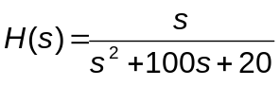

Then:-

EDU» nc =[1 0]; dc =[1 100 20];  EDU» bode (nc, dc) | Coefficient matrices : nc – numerator ; dc – denominator in descending powers of s  The bode command creates a bode plot of the row vectors specified

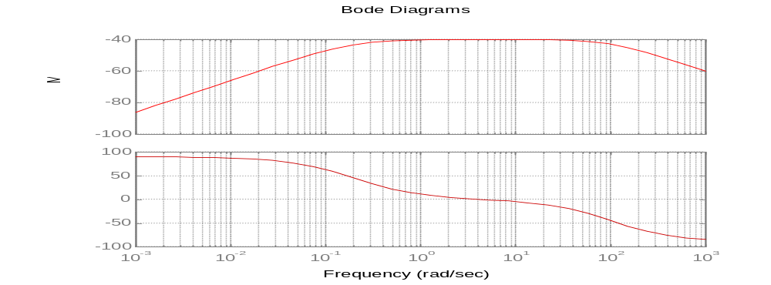

[GRAPH 1] Output produced by using the bode command on two row vectors described above.

Results/Discussions of Results and Conclusion

PART (i)

a). Bode plot (GRAPH 2 Section 1 of the appendices) shows how the magnitude of the output signal varies with frequency. From the shape of this function the system we’re dealing with is a low pass filter.

b). Bode plot (GRAPH 3 Section 1 of the appendices) shows how the magnitude of the output signal varies with frequency. From the shape of this function the system we’re dealing with is a high pass filter.

c). Bode plot (GRAPH 4 Section 1 of the appendices) shows how the magnitude of the output signal varies with frequency when [d] is smaller than [b]. It is obvious from the shape of this function the system we’re dealing with is a low pass filter.

NOTE:
This transfer function is the only function out of the eight which has the following property:- If the coefficient [d] is larger than the coefficient [b] a high pass filter is the result. If coefficients [b] and [d] are the same the filter passes through all signals, i.e. a flat response is the result.

d). Bode plot (GRAPH 5 Section 1 of the appendices) shows how the magnitude of the output signal varies with frequency. From the shape of this function the system we’re dealing with is a low pass filter.

e). Bode plot (GRAPH 6 Section 1 of the appendices) shows how the magnitude of the output signal varies with frequency. From the shape of this function the system we’re dealing with is a band pass filter.

f). This Bode (GRAPH 7 Section 1 of the appendices) plot shows how the magnitude of the output signal varies with frequency. From the shape of this function the system we’re dealing with is a high pass filter.

g). This Bode (GRAPH 8 Section 1 of the appendices) plot shows how the magnitude of the output signal varies with frequency. From the shape of this function the system we’re dealing with is a band stop filter.

h). This Bode (GRAPH 9 Section 1 of the appendices) plot shows how the magnitude of the output signal varies with frequency. From the shape of this function the system we’re dealing with is an all pass filter.

PART (ii)

Characteristics of filter type(d)

*The characteristics are graphically represented in TABLE 1 from Section 2 of the Appendices.

Question: What occurs to the output signal when [b] is increased whilst keeping [a] constant?

Starting off, when [a]=0.01, [b]=0.01

[b]=1, the overall gain of the circuit decreases by 40dB’s compared with the result produced when [b]=0.01, the cut off frequency shifts to the right by 1 decade.

[b]=100, the overall gain of the circuit decreases by 40dB’s compared with the result produced when [b]= 1, the cut of frequency shifts to the right by 1 decade.

Increasing [b] by a factor of 100 results in an increase in the gain of +40dB’s. However, there is also a resultant positive frequency shift in the cut off frequency w_{co}, which is dependant on the value of [a]. The result of choosing particular values of [a] whilst increasing [b] is shown below:

When [a]=0.01,1.0 &100.0, increasing [b] by a factor of 100 results in a linear shift of the waveform in the frequency domain by a factor of 10.

Linear frequency shift (Lfs) = √ [b]

[b] = (Lfs)²

Question: What occurs to the output signal when [a] is increased whilst keeping [b] constant?

The band pass level has the same magnitude in all instances.

Using higher [a] values decreases the value of the band pass gradient by forcing the band pass peak to move clock wise by approximately 45 degrees whence the value of [a] is increased by a factor of 100.
Characteristics of filter type(f).

*The characteristics are graphically represented in TABLE 2 from Section 2 of the Appendices.

Question: What occurs to the output signal when [b] is increased whilst keeping [a] constant?

Starting off when [a]=0.01 and [b]=0.01:

when[b]=0.01, gain pass band stays at the same dB level, independent of the value of [b]. Waveform is frequency shifted by 10rad/sec to the right.

when[b]=1.0, gain pass band stays at the same dB level, independent of the value of [b]. Waveform is frequency shifted by 10rad/sec to the right.

when[b]=100.0, gain pass band stays at the same dB level, independent of the value of [b]. Waveform is frequency shifted by 10rad/sec to the right.

Hence:

Similar characteristic as the low pass filter circuit. When [a]=1. Increasing [b] by a factor of 100 results in an increase in the frequency shift by a factor of 10. However, the gain-pass-band level stays constant and is independent of the value of [b].

Linear frequency shift (Lfs) = √ [b]

[b] = (Lfs)²

Question: What occurs to the output signal when [a] is increased whilst keeping [b] constant?

The band pass level has the same magnitude in all instances.

Using higher [a] values increases the value of the band pass gradient by forcing the band pass peak to move anti-clock wise by approximately 45 degrees whence the value of [a] is increased by a factor of 100 (opposite to the property encountered for Filter type(d)).

Characteristics of both filters

There is always a 40dB/decade drop off slope for the filter regardless of the values of K, [a] & [b].

Increasing [b] by a factor of 100 results in an increase in the frequency shift by a factor of 10.

PART(iii)

Question: What happens if you introduce a gain constant (K)?

* The graphical representations can be found in Section 3 of the Appendices

The effect of increasing K on filters type(d) and (f):-

Looking at each set of diagrams individually for the type(d) filter, the effect that K(the gain constant) has on the signal is described as follows:-

Take for example when [a]=1.0, [b]=1.0 and K=0.01. Filter type(d) has a –40db pass band below approximately 3 rad/sec, with a 40dB per decade fall-off above 3 rad/sec.

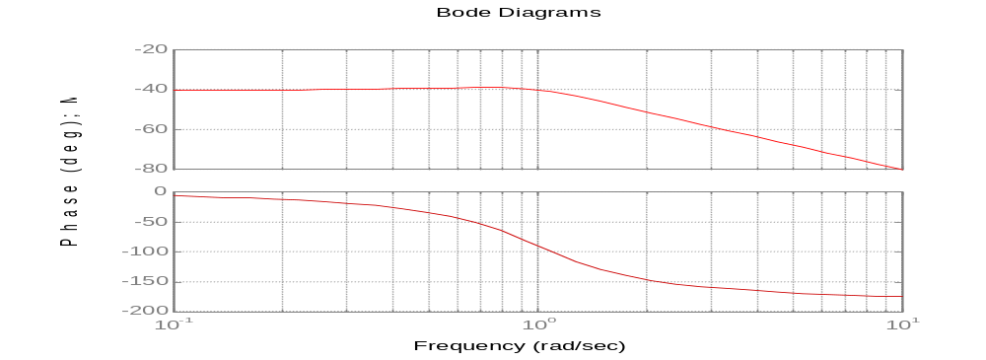

[GRAPH 10]

Using the same A and B values but increasing K to 1. Filter(d) now has a 0db pass band below approximately 3 rad/sec, with a 40dB per decade fall-off above 3 rad/sec. The gain of the filter has increased by 40dB’s.

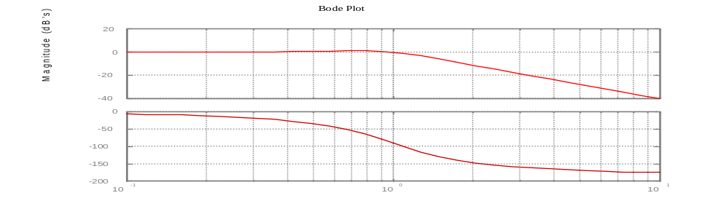

[GRAPH 11]

Again using the same [a] and [b] values but now increasing K to 100. The attributes of the circuit stay the same, but the overall gain of the filter is 40dB’s.

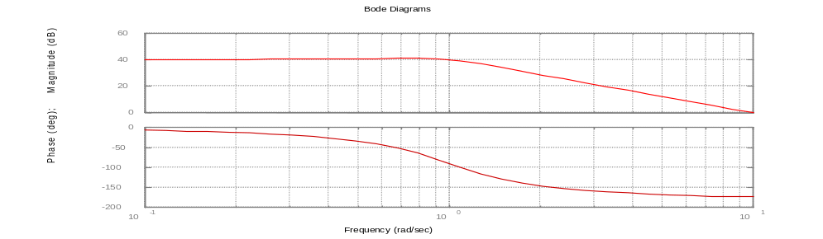
[GRAPH 12]

Filter type(d) has a different transfer function to filter(f), however by flipping filter(d)’s waveforms about the frequency axis, the output of filter(f) can be easily visualised.

This increase in the gain of the filter can be said for all the other instances for both the filters; where [a] and [b] kept constant, an increase in K by a factor of 100 results in an increase in the gain of the filter by 40dB’s.

PART(iv)

Design a low pass filter with a near-unity-gain pass-band below 1kHz and a 40 dB per decade fall-off above 1kHz.

The two filters which have been systematically tested are filter type(d) (a low pass filter) and filter type(f) (a high pass filter). Both filters produce a gain fall off of 40dB’s which is a characteristic of these 2nd order filter.

Filter(d) shall be used to in creating the filter attributes described by the assignment.

Using the filter characteristics data obtained from part(ii) and (iii) a more formularised approach can be taken:-

1). [b] = (Lfs)²

2). Gain variation (G_{var}) = 40n
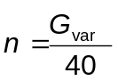

K = 100^{n}

3). Slope variation (S_{var}) = 45n (45 is 45 degrees)
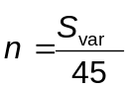

[a] = 100^{n}

The filter can be created easily using various combinations of the [a], [b] and K coefficients.

The value of K & [a] shall be set to 1 initially, but will be used closely to tweak the gain pass band level.

Okay, using the transfer function of filter type(d):

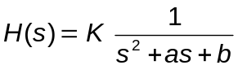

The cut off frequency of the low pass filter needs to be at approximately 1kHz which in angular frequency terms is:

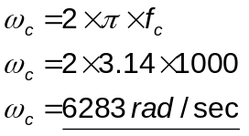

Hence from the start off point [a]=1.0, [b]=1.0, K=1.0 (GRAPH2 Section1 of Appendices) the cut off frequency needs to be shifted 6283 rad/sec to the right.

[b] is known, it’s just the cut off frequency (which in this case equals the linear shift frequency) all squared,. Hence:

[b] = (Lfs)² = 6283 = 39476089 rad/sec

With values of K,[a] &[b] set initially at 1, 1 & 39476089 respectively the initial graph can now be evaluated.

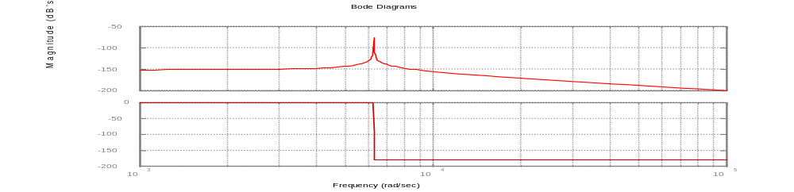

[GRAPH 13]

The bode diagram shows the correct cut off frequency. However, there is a spike on the transition from pass to rejection band (a result of a small [a] value). Also the gain pass band is at –150dB’s, 150dB’s down from unity gain.

Firstly to boost the Gain, the gain constant (K) will need to be used to increase the band pass to the 0dB level. The equation approximated for K is:

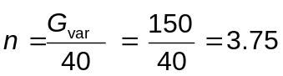

K = 100^{n} = 100^{3.75} = 31622777

Plugging the value for K into the transfer function equation along with the value for [b], we have (still keeping [a] equal to 1):

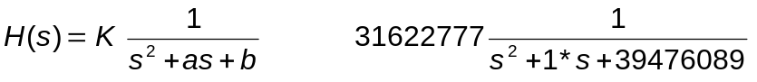

The graphical representation of this transfer function is:-

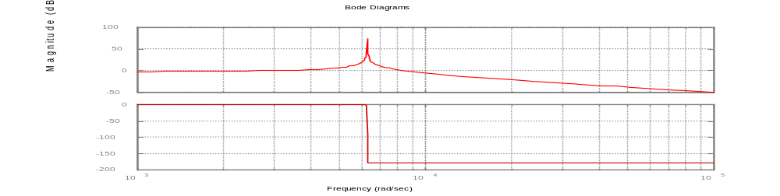
[GRAPH 14]

To achieve a smooth transition from pass to reject band i.e. eliminating the spike, the [a] coefficient must be increased sufficiently. The spike is at a vertical stance, to smooth the spike we want to “rotate” it approximately 90 degrees to the right. Hence the value of [a] used is:

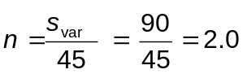

[a] = 100^{n} = 100² = 10000

Hence the complete transfer function is:

The graphical representation of the complete transfer function is:-

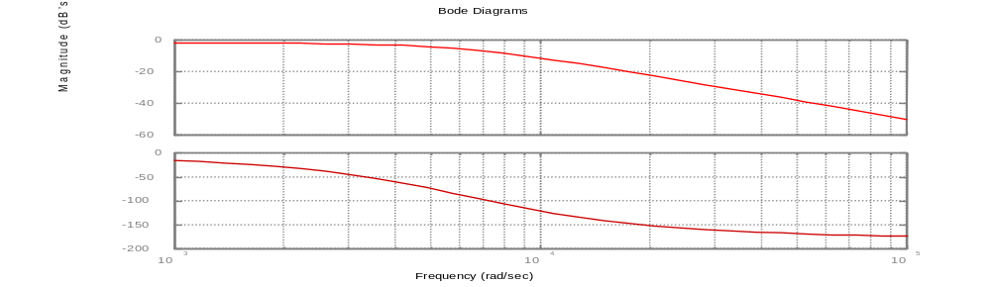

[GRAPH 15]

The response has a definite 40dB per decade fall-off above 6300 rad/s. The pass band isn’t however unity, but for the purposes of this exercise good enough, to get a better approximation a more accurate value of K would be required.

PART(v)

Design a high pass filter with a near-unity-gain pass-band above 1kHz and a 40 dB per decade fall-off below 1kHz.

If PART(v) is gone about in the same fashion as PART(iv) i.e. interpretation of graphical results leading to formula, then this should be as logical as before. Knowing that Both Transfer functions share the same denominator (both circuits share the same input voltage characteristics, only difference being the output voltage characteristics). Both functions will obviously share some properties.

Filter type(f) shall be used to in creating the filter attributes described.

Using the filter characteristics data obtained from PART(ii) and (iii)

1). [b] = (Lfs)²

2). Slope variation (S_{var}) = 45n (45 is 45 degrees anticlockwise)

[a] = 100^{n}

Because the properties of both filters are greatly similar (both filters should require the same [a] and [b] values). Lets use those [a] and [b] values acquired from PART(iv) and plug those into the transfer function of filter type(f), keeping the value of K at an initial value of 1.0 i.e. K is not in effect (K shouldn’t need to be used because altering [a] and [b] does not effect the gain pass band level). The transfer function and it’s relative coefficients are:-

The bode plot produced is:-

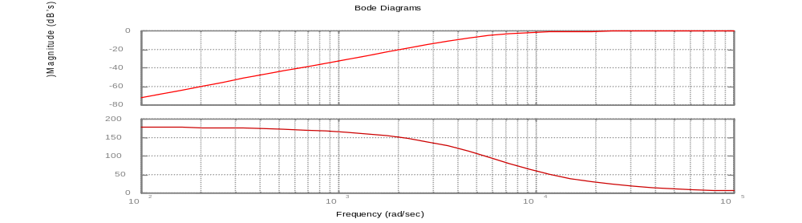

[GRAPH 16]

Great! The results acquired from the graphs of PART(ii) & (iii) and some simple formulas which connect the properties of filters type (d)&(f) have given the required information to get the correct transfer function H(s) of this high pass filter.

PART(vi)

1).
The transfer function from PART(iv) is:-

(EQUATION 1)

The transfer function of the active low pass filter is :-
(EQUATION 2)
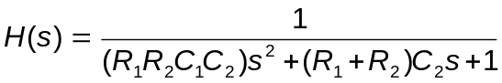

Overlapping the transfer function of PART(iv) with the transfer function of the active low pass filter:-

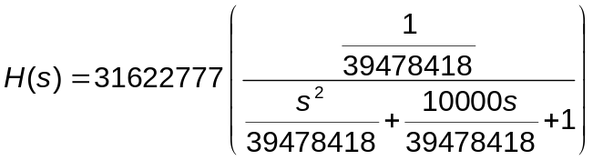
(EQUATION 3)

Which reduces to:-

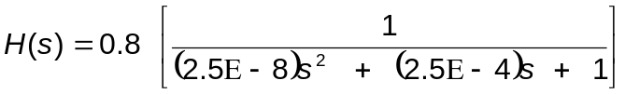
(EQUATION 4)

Thus:-

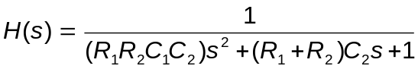
(EQUATION 5)
(EQUATION 6)
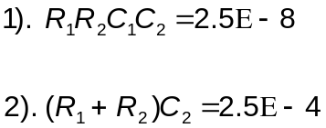
(EQUATION 7)

If R₁ and R₂ are taken to be 1ohm, because resistances are not frequency dependant, by choosing their values to be arbitrarily 1, the transfer function simplifies to nicely to a function that has only frequency dependant components. The values of these reactive components are related to the relative constants shown below. The equations above now simplify to:-

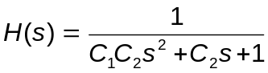
(EQUATION 8)

Hence:-

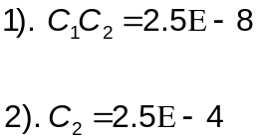
(EQUATION 9)
(EQUATION 10)

If (EQUATION 9) is now rearranged in terms of C₁, plugging in the value for C₂ from (EQUATION 10) we have:-

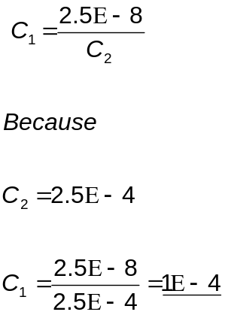
(EQUATION 11)
(EQUATION 12)
(EQUATION 13)

If we now look to the real world for these components The closest possible values for each of these components is:-

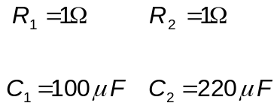

It can be seen that the component values needed for the active low pass filter are not too far off those values calculated in the preceding equations. R₁, R₂ and C₁ are readily available at a low cost from any electronics store (Maplins, RS), Not available is a 250uF capacitor, which C₂ is required to be, the closest to this value is a 220uF capacitor, using this component value wont change the characteristics of the filter too much for it to be distinguishable. If these component values are now put into the Transfer function for the low pass filter, H(s) can now be written as:

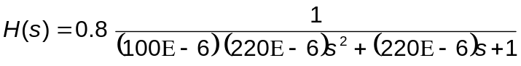
(EQUATION 14)

For all tends and purposes the gain constant can be disregarded, as it is near enough unity value, hence:-

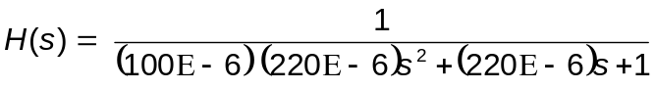

The frequency response of this particular Transfer function is:-

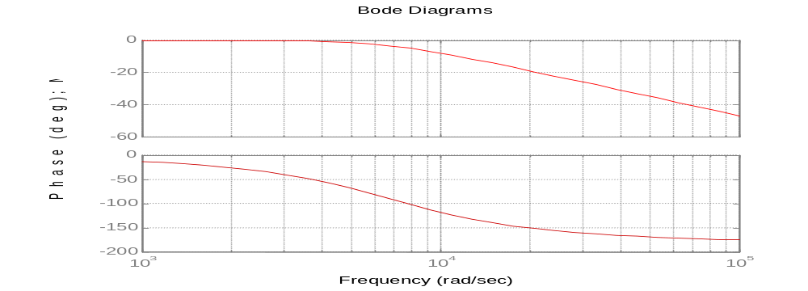

[GRAPH 17]

Looking at GRAPH 17 the filter response is in one respect better than that designed in PART(iv), the component values used have created a unity-gain-pass-band. However the cut off frequency isn’t exactly 6300 rad/s which was true in the previous design. The characteristic 40dB fall off still remains, which all 2nd order filters exhibit.

2).
The transfer function from PART (iv) is:-

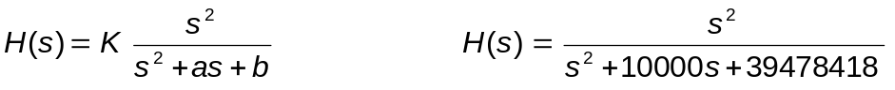
(EQUATION 15)

The transfer function of the active high pass filter is :-

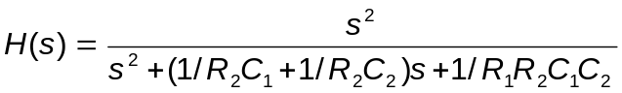
(EQUATION 16)

Overlapping the transfer function of (EQUATION 15) with the transfer function of (EQUATION 16) gives:-

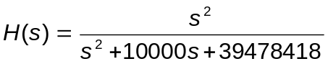
(EQUATION 17)

Which is in exactly the same form as (EQUATION 15), from this it can be said that:-
(EQUATION 18)
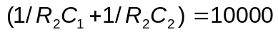 and
(EQUATION 19)
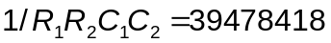

If as before, the resistances are taken to be 1 ohm, values for C₁ and C₂ can be appropriately calculated. Thus the above equations become:-
(EQUATION 20)
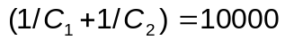 and
(EQUATION 21)
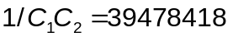

(EQUATION 20) can be written as
(EQUATION 22)
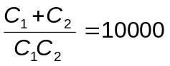
Knowing that:-

(EQUATION 23)

(EQUATION 16) simplifies to:-
(EQUATION 24)
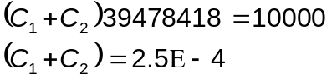
(EQUATION 25)

There are two relationships connecting C₁ and C₂ to a constant as shown below:-
(EQUATION 26)
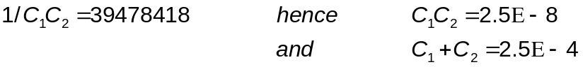
(EQUATION 27)

From these relationships it could be all well and easy rearranging the equations in terms of C₁, then C₂ . If this method is used C₁ and C₂ work out to be complex numbers, even transforming these into the real domain, negative capacitances are achieved, which are of no use.
So, real positive value capacitances are needed, this requires a systematic insertion of C₁ and C₂ values which satisfy the constants in the above two equations.
Through trial and error the values which satisfy the above two equations the best are:-

C₁= 2E-4F
C₂= 1.25E-4F

If we now look to the real world for these components The closest possible values for each of these components is:-

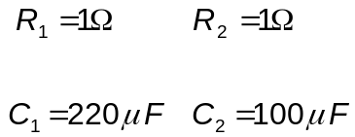

Notice these component values are exactly the same as the component values used for the low pass filter. This is to be expected, as found out in PART(iv) and (v), the [a] and [b] coefficients used in the high and low pass filter were the same.

H(s) can now be written as:

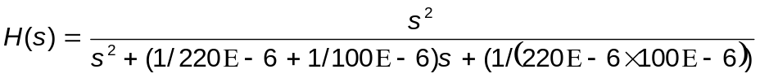
(EQUATION 28)

The frequency response of this particular Transfer function is:-

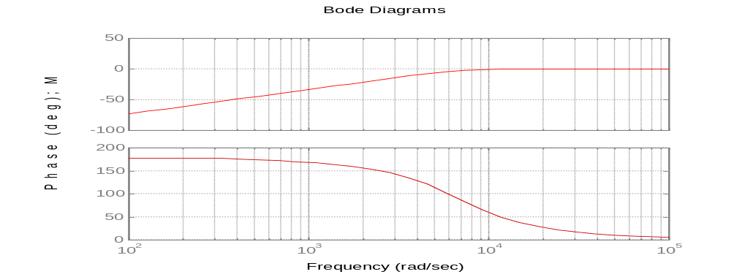
[GRAPH 18]

As you can see the frequency response is indistinguishable from that of GRAPH 16 in PART(v). This means that the design requirements described at the start of PART(v) are still met.

PART(vii)

Butterworth Filter

Beginning with the Butterworth filter, giving this first command:-

[b,a]=butter(4,1,'s')

Matlab creates a filter where 4 specifies the order of the filter, 1 specifies the cutoff frequency of the filter in rad/s, and s specifies that we are concerned with an analogue filter and its s domain transfer function. The command returns a row vector b giving the coefficients in the numerator of the transfer function, and a row vector a giving the coefficients in the denominator of the transfer function. The printout resulting from the command is:-

b =

0 0 0 0 1.0000
a =

1.0000 2.6131 3.4142 2.6131 1.0000

The transfer function of this filter is therefore:-

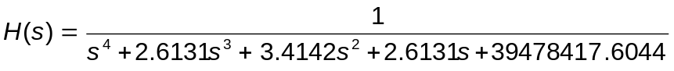

Plotting the frequency response of this function using the Matlab syntax

bode(b,a)

The graphical output achieved is:-

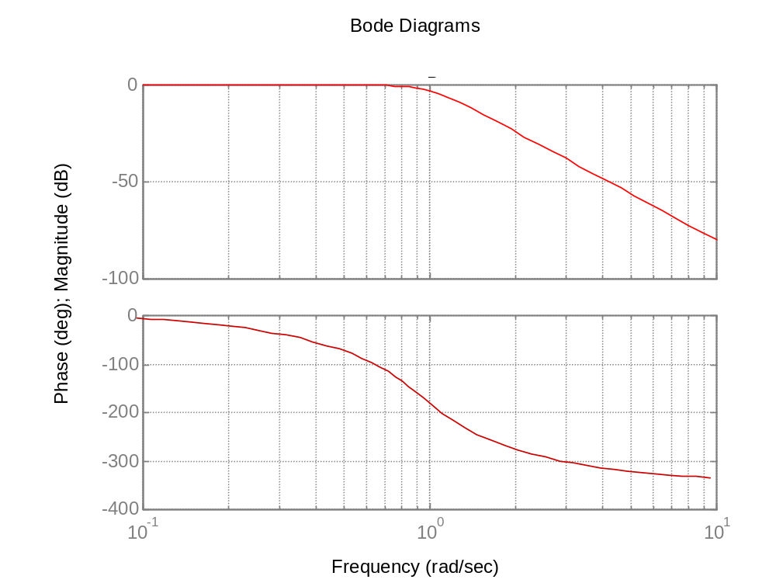

[GRAPH 19]

Chebyshev Filter

There are two types of Chebyshev filters, cheby1 and cheby2. The following Matlab commands are used to simulate a type I Chebyshev filter.

[b,a]=cheby1(4,.9,1,'s')

where 4, 1 and s are as before but .9 is added to specify the allowable passband ripple in dB’s. Note also that the cutoff frequency of 1 rad/s now refers to the frequency where the gain is reduced from the zero frequency gain by the specified ripple of 0.9 dB; it does not refer to the –3dB frequency.

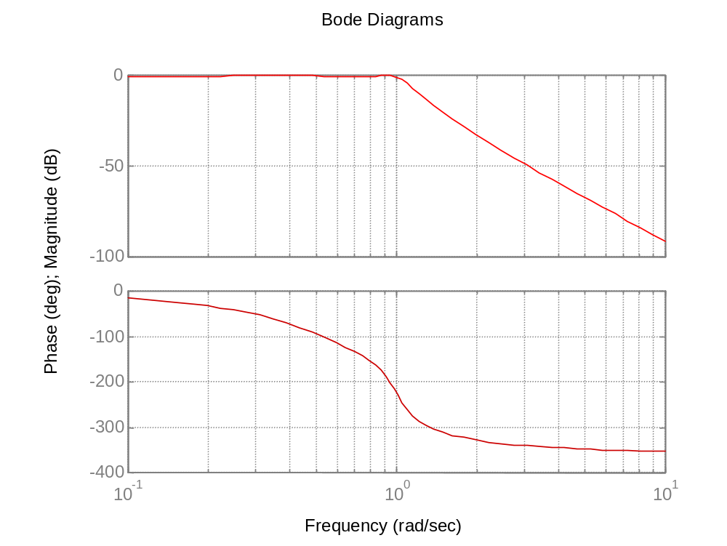[GRAPH 20]

Cheby1 signifies that we are under taking a Chebyshev type I filter design in which the passband ripple is controlled (and contrasts with cheby2 which is for a type II design where the stopband ripple is controlled).

The following Matlab commands are used to simulate a type 2 Chebyshev filter.

[b,a]=cheby2(4,.9,1,'s')

The layout of the commands are the same as before, .9 signifies the stopband ripple allowed.

The printout resulting from the command is:

b =

0.9016 0 7.2126 0.0000 7.2126

a =

1.0000 1.4433 7.5442 2.1871 7.2126

The graphical output response is:-

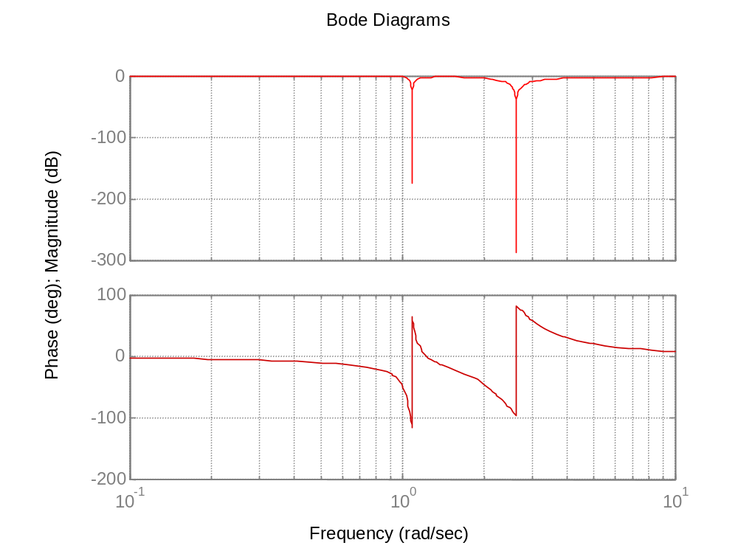

[GRAPH 21]

Elliptic Function

For the elliptic function filter the necessary commands are

[b,a]= ellip(4,.9,50,1,'s')

bode(b,a)

where 4, .9, 1 and s are as for the Chebyshev filter but 50 is added to specify that after the monotonic increase of the attenuation in the stopband to 50 dB, stopband ripple is then acceptable so long as the attenuation never falls below 50 dB.

The graphical output is shown below:-

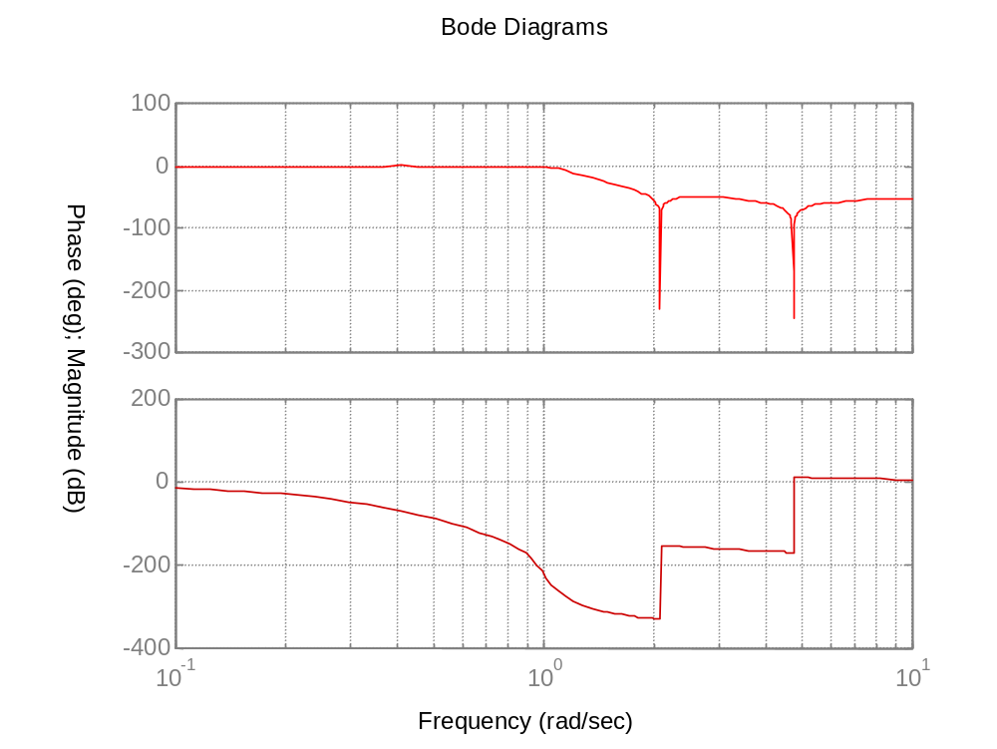

[GRAPH 22]

Comparison of Transfer Function Coefficients

Transfer function coefficients obtained from part (iv) (lowpass filter):-

[a] = 10000
[b] = 39478418
K = 31622777

Transfer function coefficients obtained from part (v) (highpass filter):-

[a] = 10000
[b] = 39478418
K = 1
Lets see what Transfer function coefficients the Butterworth command produces when given the design requirements of Part(iv) and (v).

Lowpass Butterworth Filter:

EDU» [b,a]=butter(2,6300,'s')

b =

0 0 39690000

a =

1.0e+007 *

0.0000 0.0009 3.9690

EDU» bode(b,a)

Response when the above Matlab syntax is used:-

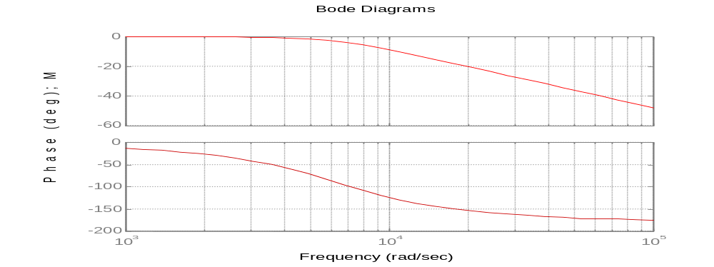

[GRAPH 23]
Notice that the Transfer function coefficients [a], [b] and K are 9000, 39690000 and 31622777 respectively. Compare this with coefficients achieved in the design (top of page 21). There is a difference of 1000, 200000 and 8000000 in the [a], [b] and K coefficients respectively. There is a large error in the result obtained for the value of K.

Highpass Butterworth Filter:

EDU» [b,a]=butter(2,6300,0,'s')

b =

1 0 0

a =

1.0e+007 *

0.0000 0.0009 3.9690

EDU» bode(b,a)

Produces a second order high pass filter that passes frequencies above 6300 rad/s. The response is shown below:-

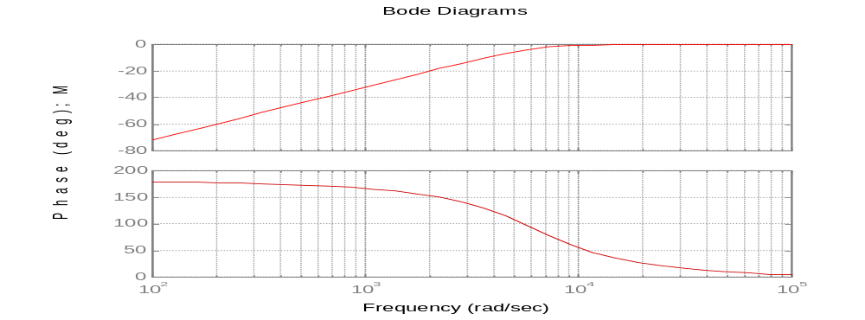
[GRAPH 24]

The Butterworth filter has a nice flat bandpass response, however the roll-off can be better as shown in the Chebyshev response.
Notice that the Transfer function coefficients [a], [b] and K are 9000, 39690000 and 1 respectively. Compare this with coefficients achieved in the design (top of page 21). There is a difference of 1000, 200000 and 0 in the [a], [b] and K coefficients respectively. The inaccuracy in my formulated K result doesn’t effect the characteristics of the high pass filter, hence the high pass filter response is closer to the ‘ideal’ Butterworth response.

Lowpass Chebyshev Filter type(i):

Lets try the Chebyshev Filter(i) response with a very low pass band ripple value.

EDU» [b,a]=cheby1(2,.1,6300,'s')

b =

1.0e+008 *

0 0 1.3003

a =

1.0e+008 *

0.0000 0.0001 1.3153

EDU» bode(b,a)

This lowpass response is shown below:-

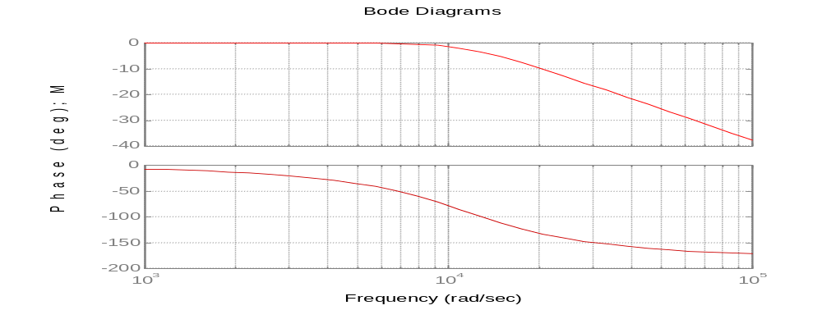
[GRAPH 25]

Notice that the Transfer function coefficients [a], [b] and K are 10000, 131530000 and 130030000 respectively. Compare this with coefficients achieved in the design (top of page 21). There is a difference of 0, 90551582 and 99907223 in the [a], [b] and K coefficients respectively. There is a large error in the result obtained for the value of [b] and K.

Highpass Chebyshev Filter type(i):

The syntax used to create a 2nd order high pass Chebyshev filter response:-

EDU» [b,a]=cheby1(2,.1,6300,0,'s')

b =

0.9886 0 0

a =

1.0e+007 *

0.0000 0.0005 1.1976

EDU» bode(b,a)

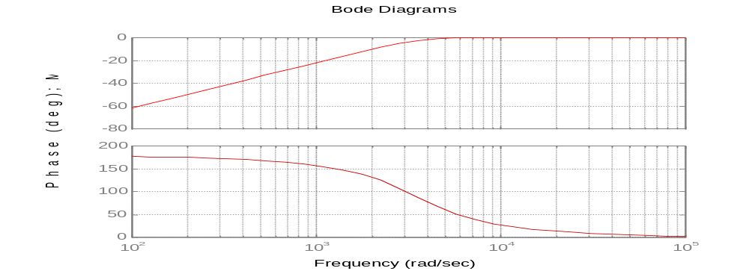
[GRAPH 26]

Notice that the Transfer function coefficients [a], [b] and K are 5000, 12000000 and 0.9886 respectively. Compare this with coefficients achieved in the design (top of page 21). There is a difference of 5000, 27502418 and 0.0114 in the [a], [b] and K coefficients respectively. There is a large error in the result obtained for the value of [a] and [b].

Main Conclusions

1). If an s-domain transfer function has the following:-

- unity as its numerator, the characteristic of that particular system, is to pass the low frequency component of the signal i.e. a low pass filter.
- a power of s in its numerator, if the order of s is the same as the order of the polynomial on the denominator a high pass filter characteristic is achieved.
- A power of s in the numerator, which is one order lower than the order of the polynomial in the denominator a band pass filter characteristic is achieved.

2). The coefficients associated with a second order low/high pass filter i.e. K, [a] & [b] effect the filter response as follows:

- There is always a 40dB/decade drop off slope for the filter regardless of the values of K, [a] & [b].
- Increasing [b] by a factor of 100 results in an increase in the frequency shift by a factor of 10.
- An increase in K by a factor of 100 results in an increase in the gain of the filter by 40dB’s.
- For a high pass filter using higher [a] values increases the value of the band pass gradient by forcing a peak in the band pass to move anti-clock wise by approximately 45 degrees whence the value of [a] is increased by a factor of 100 (opposite to the property encountered for the low pass filter).

3). Applying properties obtained from graphical results (shown in the 1st and 2nd part of the conclusion), any low/high pass filter can be designed with a 40 dB per decade fall-off and have one particular cut off frequency with any required gain pass band.

4). The active filter Transfer functions can be easily integrated with the Transfer functions of a standard filter (which is met in PART(iii)). Using the R&C values in place of the normal coefficients K, [a] & [b], the filter response remains very close to the original response. This means that the design requirements described at the start of PART(iv) and (v) are met.

5). The main merits of the Butterworth filter responses are their flatness in the passband. If the order of the Butterworth filter is made large the filter takes a sharp rate of cut-off, thus becoming a closer approximation to the brick wall response. The Chebyshev response permits a small amount of ripple in the passband and, in return, gives a sharper cut-off than the Butterworth response for the same amount of filter elements. In the elliptic function (or Cauer) filter, ripple is allowed in the stopband as well as in the passband. The consequence is that, for a given order of filter, the roll-off rate of the filter becomes even greater than that of the Chebyshev filter.
6). Out of the filter responses explored in PART(vii); my results obtained in PART(iv) and (v) more closely matched the Butterworth filter response and its Transfer function coefficients. This makes the Butterworth filter the favourite choice if simplicity is the aim of a filter design, also it offers that nice flat bandpass response.

References

- D.E Gray, ‘Writing a technical Paper’, Physics Education, 1967, Vol. 2, p. 81-88
- System Analysis & Signal Processing, Denbigh, Chapter 12
- Introduction to Electrical Circuits, Dorf & Svoboda, Chapter 14
- The Analysis and Design of Linear Circuts, A.J.Rosa, Section 12

